Rockbuster Stealth

Data Dictionary

Aysha Samsudeen

- Entity Relationship Diagram (ERD) 3
- Tables 4
  - Fact Tables 4
Payment 4
Rental 4
  - Dimensions Tables 5
Film_actor 5
Inventory 5
Film_category 5
Customer 6
Staff 6
Actor 7
Film 7
Category 8
Language 8
Address 8
City 9
Country 9

Entity Relationship Diagram (ERD) :

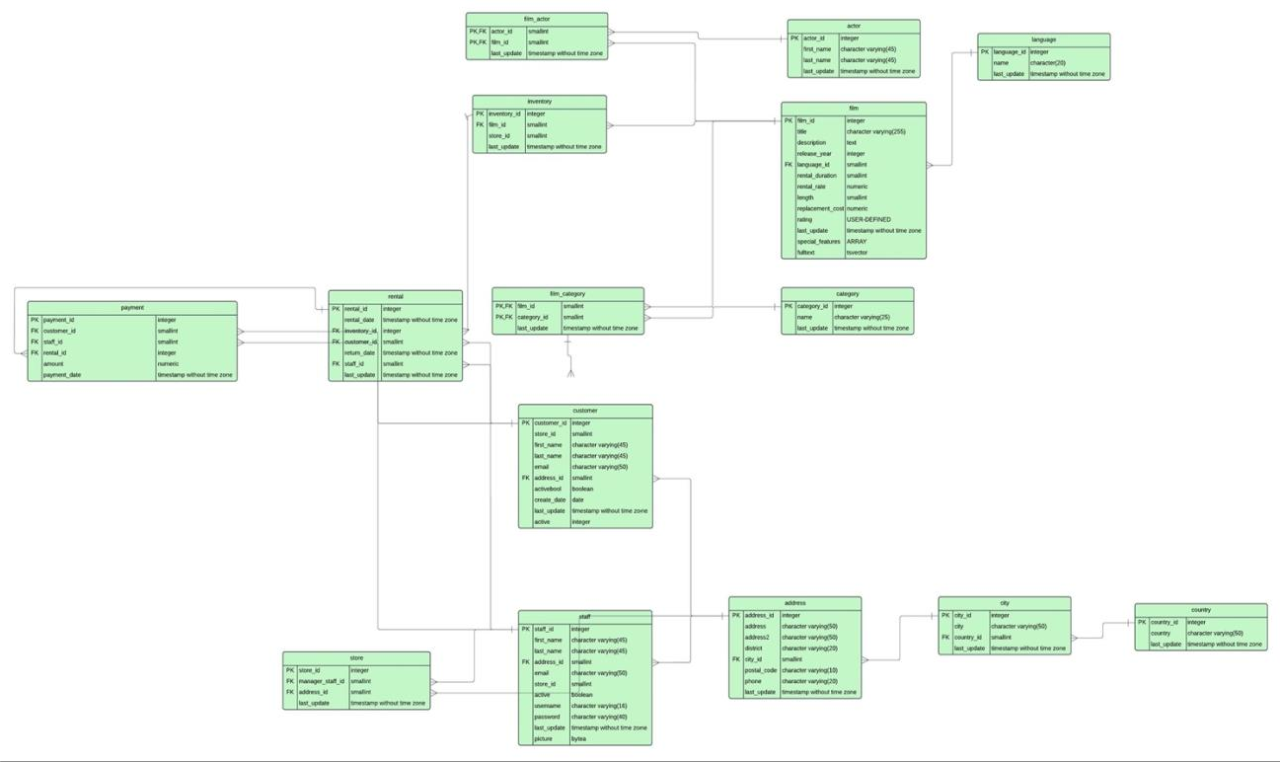

- Tables :

Fact Tables :

Payment

Column | Data Type | Description | Column linked  to | Column linked  from
payment_id | SERIAL | Each payment has a unique ID number
customer_id | SMALLINT | Each customer is given an ID number(small integer values) | customer.  customer_id | rental.customer_id
staff_id | SMALLINT | Each staff is given a unique ID number ( small integer values) | staff.staff_id | rental.staff_id
rental_id | INTEGER | Each rental is given a unique ID number ( small integer values) | rental.rental_id
amount | NUMERIC(5,2) | Money spent on each film that is rented
payment_date | TIMESTAMP(6) WITHOUT TIME ZONE | date and time  payment was made/confirmed

Rental

Column | Data Type | Description | Column linked to | Column linked from
rental_id | SERIAL | Each given a ID no( unique identifier number) |  | payment.rental_id
rental_date | TIMESTAMP(6)  WITHOUT TIME ZONE | Each film has a rental date/ a date it is rented out
inventory_id | INTEGER | Unique indetifier number for each rental date | inventory. inventory_id
customer_id | SMALLINT | Each customer has a unique identifier number | customer. customer_id | payment. customer_id
return_date | TIMESTAMP(6) WITHOUT TIME ZONE | Each film has a return rental date
staff_id | SMALLINT | Each staff member has a unique staff number ( small integer values) | staff.staff_id | Payment  staff_id

Dimension Tables:
Film_actor

Column | Data Type | Description | Column linked to | Column linked from
actor_id | SMALLINT | unique identifier numbers for actor. | actor.actor_id
film_id | SERIAL | unique identifier of films | film.film_id
last_update | TIMESTAMP(6) WITHOUT TIME ZONE | The information entered in the table last updated on a data and time (The time with up to 6 digits)

Inventory

Column | Data Type | Description | Column linked to | Column linked from
inventory_id | SERIAL | Each inventory given a ID no- unique identifier numbers | rental. inventory_id
film_id | SMALLINT | Each film given a number id (small integer values) | film.film_id
store_id | SMALLINT | Each store given a number id (small integer values) | store.store_id
last_update | TIMESTAMP(6)  WITHOUT TIME ZONE | The information entered in the table last updated on a  data and time (The time with up to 6 digits)

Film_category

Column | Data Type | Description | Column linked to | Column linked from
film_id | SMALL INT | Each film has a unique film identifier | film.film_id
category_id | SMALLINT | Films are categorized by ID numbers | category. category_id
last_update | TIMESTAMP(6) WITHOUT TIME ZONE | date and time of last record update

Customer

Column | Data Type | Description | Column linked to | Column linked from
customer_id | SERIAL | unique identifier of customer | rental. cusomer_id payment.  customer_id
store_id | SMALLINT | Unique store identifier
first_name | CHARACTER  VARYING(45) | customer first name (Different up to 45 characters)
last_name | CHARACTER VARYING(45) | customer last name (Different up to 45 characters)
email | CHARACTER  VARYING(50) | customer email  address
address_id | SMALLINT | Unique identify number for customers |  | address.  address_id
activebool | BOOLEAN | The state of the customers if they are active or inactive members give “True or False” (True or false values of 0 and 10)
create_date | DATE | date customer’s profile was created
last_update | TIMESTAMP(6) WITHOUT TIME ZONE | The information entered in the table last updated on a data and time
active | INTEGER | A state of the customers if they are active or inactive members give a value  (integer values)

Staff

Column | Data Type | Description | Column linked to | Column linked from
staff_id | SERIAL | unique identifier number of  staff
first_name | CHARACTER VARYING(45) | staff first name (45 characters)
last_name | CHARACTER VARYING(45) | staff last name ( 45 characters)
address_id | SMALLINT | Each address given an ID number) | address.  address_id
email | CHARACTER  VARYING(50) | staff email address
store_id | SMALLINT | Each store given a unique identifier | store.store_id
active | BOOLEAN | active or not (true/false) | rental.staff_id, payment.  staff_id
username | CHARACTER  VARYING(50) | staff username
password | CHARACTER VARYING(40) | staff password
last_update | TIMESTAMP(6) WITHOUT TIME ZOND | date and time of last record update
picture | BYTEA | staff photo

Actor

Column | Data Type | Description | Column linked to | Column linked from
actor_id | SERIAL | unique identifier number of actor | film_actor. actor_id
first_name | CHARACTER VARYING(45) | actor first name
last_name | CHARACTER  VARYING(45) | actor last name
last_update | TIMESTAMP(6)WITHOUT TIME ZONE | The information entered in the table last updated on a data and time (The time with up to 6 digits)

Film

Column | Data Type | Description | Column linked to | Column linked from
film_id | SERIAL | unique identifier of film | film_category. film_id, film_actor.  film_id, inventory.film_id
title | CHARACTER VARYING (255) | title name of film( 255 characters)
description | TEXT | description of film
release_year | year | year film was  released
language id | SMALLINT | Each film language - each language given a number id (small integer values) | language. language_id
rental_duration | SMALLINT | number of days film was rented for
rental_rate | NUMERIC(4,2) | Price of each film rented per day
length | SMALLINT | film length (minutes)
replacement_cost | NUMERIC(5,2) | cost to replace the film
rating | mpaa_rating | which age groups can view the film (G, PG,PG-13, ect)
last_update | TIMESTAMP(6)  WITHOUT TIME ZONE | The information entered in the table last updated on a data and time
special_featur es | TEXT[] | special features of the film/genre
fulltext | TVSECTOR | Each film key words (Functions for full text search)

Category

Column | Data Type | Description | Column linked to | Column linked from
category_id | SERIAL | Each film genre | film_category.  category_id
name | CHARACTER  VARYING(25) | category name
last_update | TIMESTAMP(6)WITHOUT TIME ZONE | date and time of last  record update

Language

Column | Data Type | Description | Column linked to | Column linked from
language_id | SERIAL | Each language given a number id - unique identifier values | film.language_id
name | CHARACTER(20) | Each film language - made up of 20 characters or more
last_update | TIMESTAMP(6) WITHOUT TIME ZONE | The information entered in the table last updated on a  data and time

Address

Column | Data Type | Description | Column linked to | Column linked from
address_id | SERIAL | Each store has been given a unique ID no | staff.address_id, store.  address_id
address | CHARACTER VARYING(50) | Each customer and staff main address
address2 | CHARACTER  VARYING(50) | Each customer and staff address - (Different characters up to 50 characters)
district | CHARACTER  VARYING(20) | name of the district
city_id | SMALLINT | Each customer and staff address - postal code/zip code (Different characters up to 10 characters) | city.city_id
postal_code | CHARACTER VARYING(10) | postal code details
phone | CHARACTER VARYING(20) | Each customer and staff phone number
last_update | TIMESTAMP(6)WITHOUT TIME ZONE | Date for each payment made

City

Column | Data Type | Description | Column linked to | Column linked from
city_id | SERIAL | Each store given a unique ID | address.city_id
city | CHARACTER VARYING(50) | Each customer and staff address - city name (Different characters up to 50 characters)
country_id | SMALLINT | Each country given a number id (small integer values) | country.  country_id
last_update | TIMESTAMP(6) WITHOUT TIME ZONE | Date for each payment made (The time with up to 6 digits)

Country

Column | Data Type | Description | Column linked to | Column linked from
country_id | SMALLINT | Each store given a id number | city.country_id
country | CHARACTER  VARYING(50) | Each customer and staff address - country
last_update | TIMESTAMP(6)WITHOUT TIME ZONE | Date of each payment

